

# Requirements Specification Document

## Final Year Project Allocation System



Table of Contents

Requirements Specification Document 0

Final Year Project Allocation System 0

Introduction 2

Use-case diagram 2

Non-functional aspects 3

Functional requirements 3

2.2 Functions and their description 3

Data description 7

Interface 9

Technical and professional issues 16

# Introduction

The Computing Department of University of Bradford (UoB) is looking to develop a new Web-based Final Year Project Allocation (FYPA) system for final year and master students. The client of the system is Karim Sadik, the Final Year Project coordinator. The projects will be stored in a database and students will have the ability to select or propose their desired project. To avoid manual work, this system will allocate projects to supervisors automatically. Furthermore, a module coordinator will act as the administrator who can add, edit or remove supervisors, projects and students.

This document is based on the provided project brief, an interview with the client and follow-up questions via email with the client where the functions, data and interface of the system were discussed.

# Use-case diagram

# Non-functional aspects

The information regarding projects that will be presented by the FYPA system has been provided by the client in a sql file called ‘FYP_table.sql’. Furthermore, the FYPA system will be hosted on the University of Bradford’s LAMP server. The LAMP server hosting the FYPA system currently supports php version 7.3 and the FYPA system will be developed using php 7.

# Functional requirements

*2.1 Actors*

There are three actors that interact with the system. The system will provide a user interface for each actor to interact with the system.

**Student**s – Final year or Master student at the University of Bradford can interact with the system. These users can view and choose projects that are displayed to them by the supervisors and module coordinator. These users can propose projects.

**Supervisors** – Academic staff added to the system by the module coordinator. These users can add, modify or delete their own projects and can view projects.

**Module Coordinator** – Acts as an administrator. This user can add, modify or delete supervisors, students and projects. They also can allocate students to supervisors and view projects.

## 2.2 Functions and their description

1. Student registration

Each student is registered with the system via a registration form. Students will register by inputting their first name, last name, UoB number, UoB email, password, their programme of study and their year of study. When the form is submitted, these details will be stored in a database. Checks will also be done to avoid duplicating students as the UoB numbers and UoB Emails held in the database for each student are unique.

1. Log in/logout for all users

One login form will be presented to all users who access the site. Students will log in with their UoB number and password. Supervisors will log in with their username and password. The module coordinator will log in with a unique ID number and password. Users can exit the system by clicking a logout button.

1. View projects

Students will only see projects that are available for their year of study for selection i.e. 3rd year students will only see available projects for 3rd year students and master students will only see available projects for master students.

Supervisors can view all projects including student proposed projects and they can view their own proposed projects.

Module coordinator can view all projects.

For each project, the initial information displayed is the project’s id number, project title, originator and project’s description. Further information about a project’s programme of work, deliverables, learning outcomes, prerequisites, requirements and external originator (if any) may also be displayed if a supervisor/module coordinator has provided this information when adding a project to the system (see function 7.1 below). Furthermore, information about whether a project has been proposed by a student will also be displayed if a supervisor or module coordinator is viewing all projects (see function 4 below).

1. Propose project

A student can propose a project by filling out a form which takes the following input information about the project: the project title, the description of the project, the programme of work, the deliverables and the supervisor that has agreed the contents of the project and to supervise it. The student proposed project is then added to the system. The information about the student proposed project will be sent to the module co-ordinator and to the supervisor that has agreed to supervise the project via email notifying them it has been added to the system. Then the module coordinator can choose to edit or delete the student’s proposed project from the system should they believe it is not suitable or it needs to be changed. (see function 7.2 and 7.3).

1. Choose project

A student can choose a project from the list of projects displayed to them. When a project is chosen, the project will not be displayed anymore on the list as it is unavailable to other students. Upon project submission, data will be sent to the database regarding who has chosen the project.

A student can only choose one project from the list and they are permitted one change of their project choice within a seven-day period from the initial selection. They will deselect their initial choice, this will make their initial choice available to other students and they will select their new choice of project. The initial selection date will be recorded, as well as the date 7 days ahead which will confirm project selection. The number of selections a student has made will also be recorded.

When a project is selected by a student an email is also composed and sent to module co-ordinator regarding the student’s first name, last name, UoB number, UoB email address, their programme of study, their year of study, the project ID and project title of the project they have selected.

1. Automatic student allocation

For student proposed projects that are submitted by the student and are added to the system (see function 4), the supervisor that agreed to supervise the project with the student, is their assigned supervisor and cannot change. However, for students that have selected a project from the list of projects, their supervisor will not necessarily be the originator of the project. The module coordinator can trigger the system to allocate these students between all supervisors to assure a roughly equal number of students are being supervised by each supervisor.

1. Handling projects

7.1 - Add projects. A module coordinator or a supervisor can add projects to the system via a form requesting mandatory information about the project title, originator, description and year of study the project is available to. Upon a supervisor’s/ module coordinator’s discretion, they can also input optional information about the programme of work, deliverables, learning outcomes, prerequisites, requirements and external originator information (if any) for a project.

7.2 - Delete projects. A supervisor can only delete their own project(s) from the system. A module coordinator can delete any project from the system.

7.3 - Edit projects. A supervisor can edit any information relating to information regarding only their project(s). A module coordinator can edit information about any project.

1. View allocated students

A supervisor can see a table of students they are supervising along with the projects allocated to each of them. The table presents the full name of the student, their UoB number, their UoB email address, their project id and their project title. A supervisor can only see the students they supervise; after the projects have been allocated across the supervisors automatically by the system (see function 6 above).

1. Handling students

9.1 - Add students. The module coordinator can add students to the system by inputting their first name, last name, UoB number, UoB email, password, their programme of study and their year of study.

9.2 - Edit students. The module coordinator can edit all information related to a student.

9.3 - Delete students. The module coordinator can delete students from the system. Upon deleting a student that has a project assigned to them, the project will become available again to all other students for selection.

1. Handling supervisors

10.1 - Add supervisors. The module coordinator can add supervisors to the system. The module coordinator adds the first name, last name, username, password and UoB email address for a supervisor.

10.2 - Edit supervisors. The module coordinator can edit all information related to a supervisor.

10.3 - Delete supervisors. The module coordinator can delete supervisors from the system. Upon deletion of a supervisor, students that were previously allocated to the supervisor are distributed amongst other supervisors.

1. View supervisors and their allocated students.

Module coordinator can see a table of supervisors, along with the students they are supervising, and the project allocated to each student. The table presents each supervisor by name and UoB email address. It also presents the name of the student, UoB number, UoB email address, the project ID and their project title for every student allocated a supervisor.

1. View allocated supervisor

Students can see details about the project they have selected or proposed such as the project’s id number, project title, project’s description and other information about a project’s programme of work, deliverables, learning outcomes, prerequisites, requirements and external originator information (if any). If they have selected a project they will see their assigned supervisor after the projects have been allocated across all supervisors automatically (see function 6 above). The student will be displayed the supervisor's name and the UoB email of the supervisor. If automatic allocation has not occurred the allocated supervisor will not be shown. A student who has proposed a project will see their assigned supervisor’s details instantly.

13) Allocate Project to Student

Module coordinator can manually allocate a project to a student who has not selected a project. By inputting the id of the project and the UoB number of the student.

14) Allocate Student for Supervisor

Module coordinator can manually allocate a student who has selected a project to a supervisor. By inputting the UoB Number of the student and the supervisor id.

# Data description

Data handled by the Final Year Project Allocation System are as follows:

Students - With fields identifying each student, the date they selected a project, the date this project cannot be deselected/changed and the number of times they’ve selected a project.

Projects - With fields identifying each project, which student is allocated the project and which supervisor is supervising the project.

Supervisors - With fields identifying all the supervisors.

Module Coordinator - With fields identifying a module coordinator.

**Students**

First name - maximum of 25 characters

Last name - maximum of 25 characters

UoB number - unique identifier of student with 8 digits which is an integer

UoB email address - maximum of 50 characters with mandatory ‘@bradford.ac.uk’

Programme of Study - description of programme students enrolled on, maximum of 50 characters

Password - minimum of 8 and maximum of 16 characters

Year of Study - maximum of 3 characters with a choice of 3rd (third year) and MSc (Masters)

Date projected selected - dd/mm/yyyy (8 digits) date and time (24 hour clock with minutes and seconds) when the projected has been selected

Date project is confirmed - dd/mm/yyyy (8 digits) date and time (24 hour clock with minutes and seconds) when student can’t change the project

Number of selections - 1 digit either 0, 1 or 2 to identify the number of times a student has selected a project

**Projects**

Project ID - unique identifier of projects which is an integer

Project Title – title of project maximum of 100 characters

OriginatorID – matches the unique identifier for supervisors and is used to find the supervisor who originated the project

Description - maximum of 2000 characters

Programme of Work - maximum of 2000 characters

Deliverables - maximum of 1000 characters

Learning Outcomes - maximum of 2000 characters

Prerequisites - maximum of 1000 characters

Requirements - maximum of 1000 characters and this is for hardware and software requirements

Year of Study - Maximum of 3 characters with a choice of 3rd (third year) and MSc

Availability - True(1) or False(0) for whether the project is available or not

Self-proposed – True(1) or False(0) for whether the project is self-proposed or not

Assigned Student - Identifies student that is undergoing this project with 8 digits

Assigned Supervisor - Identifies the supervisor managing this project

**Supervisors**

Supervisor ID - unique identifier for supervisor which is an integer

First name - maximum of 25 characters

Last name - maximum of 25 characters

Username - maximum of 25 characters

Password - minimum of 8 characters and maximum of 16

UoB email - maximum of 50 characters with mandatory “@bradford.ac.uk”

**Module Coordinator**

Module Coordinator ID - unique identifier for supervisor which is a 6-digit value

First name - maximum of 25 characters

Last name - maximum of 25 characters

Password - minimum of 8 characters and maximum of 16

UoB email - maximum of 50 characters with mandatory “@bradford.ac.uk”

# Interface

**Login page**

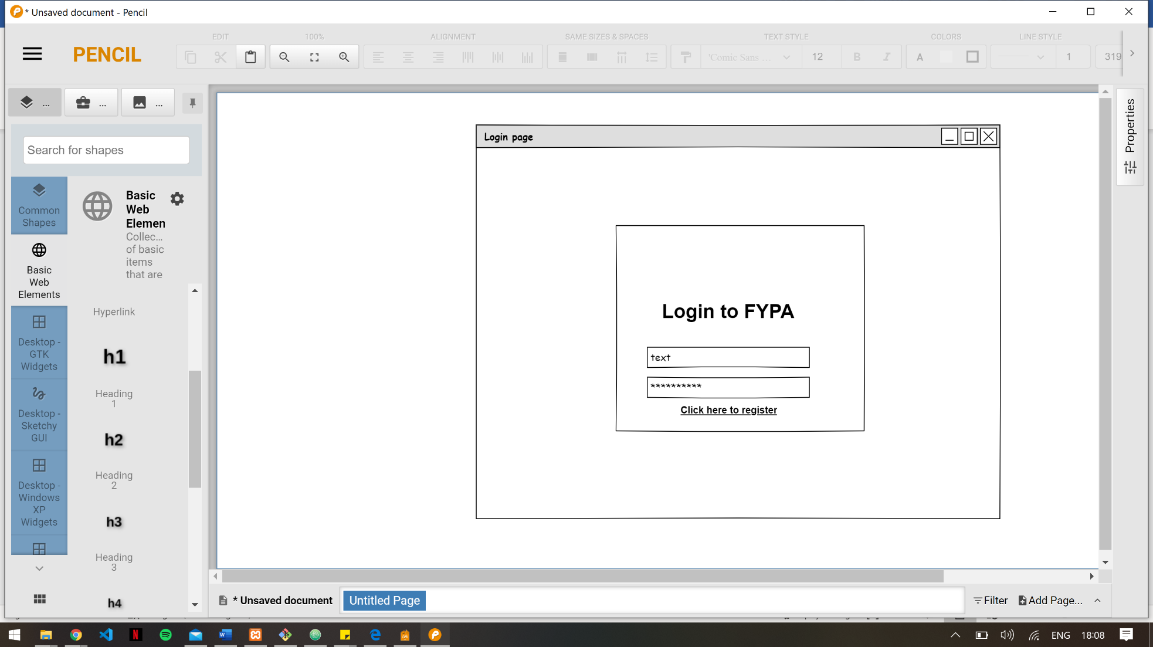

Login page allows registered students, supervisors and the module co-ordinator to login to the system.

Character and numerical check will be performed on all columns to prevent incorrect character input.

Students will log in with their UoB number and password. Supervisors will log in with their username and password. The Module Coordinator will log in with a unique ID number and password.

The login button initiates a check to see which type of user it is logging in and takes them to the desired page.

Can click the click here to register link to go the register page.

Initiate the dialogue for function 2 (Login/Logout for all users).

**Registration Page**

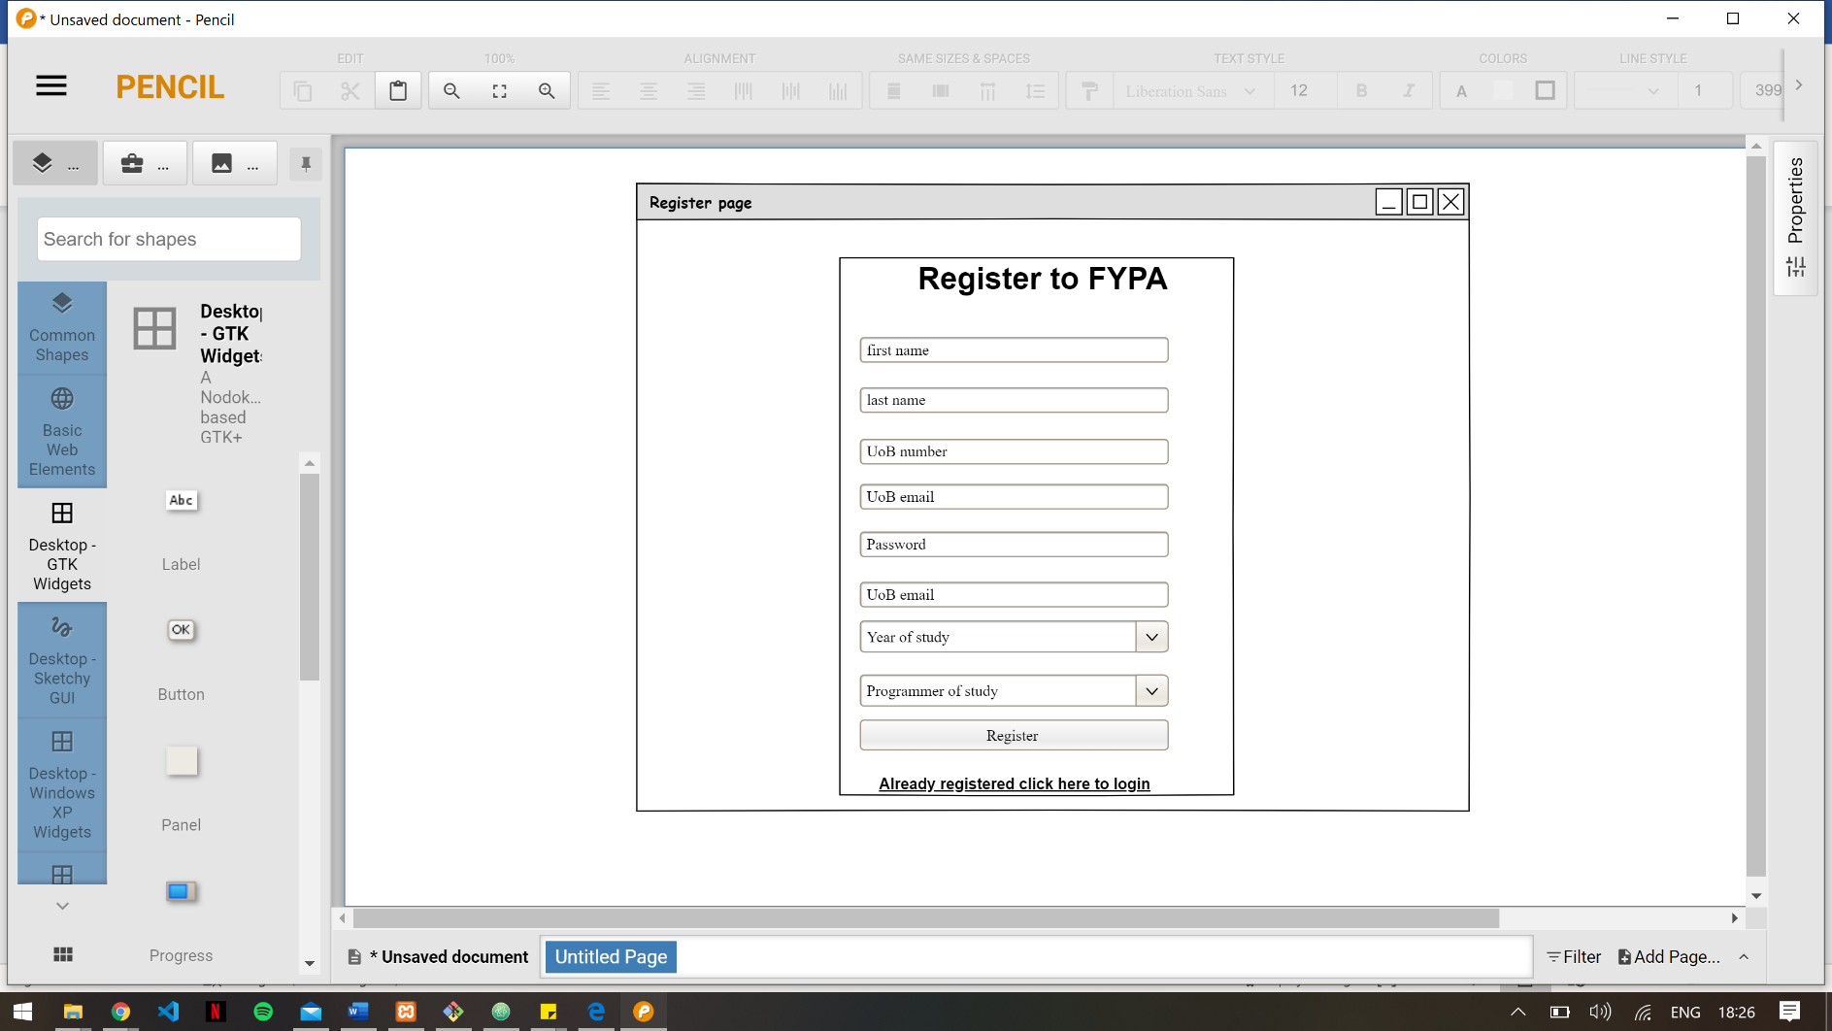

Registration page is also a form which will include student details that need to be stored in the database.

It will have a drop-down field on for the year of study and programme study fields.

Character and numerical check will be performed on all columns to prevent incorrect character input.

The register button sends the students details in the database.

Can click the already registered click here link to go to the login page.

Initiates the dialogue for function 1(student registration).

**Student Page**

This is the page students are redirected to when logged in.

Three buttons are located on the top right of the navigation bar which will be used for logging out of the FYPA system, proposing a project and viewing a student’s project.

The logout button initiates dialogue for function 2 (login/logout for all users) to logout the system and be redirected to login page.

The propose own project button presents a pop-up form to propose a project and initiate dialogue for function 4 (propose project)

The view my project button presents a pop to show a student’s project and if they are allocated a supervisor, their supervisor. It initiates function 12 (view allocated supervisor)

Table displays all the projects the student could select from (function 3 view projects).

Each project has a select button that can be used to initiate dialogue for function 5 (choose project).

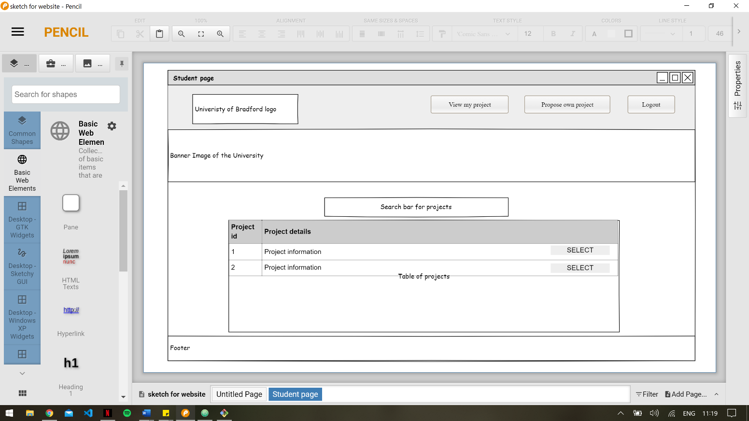

**Proposing own project pop-up**

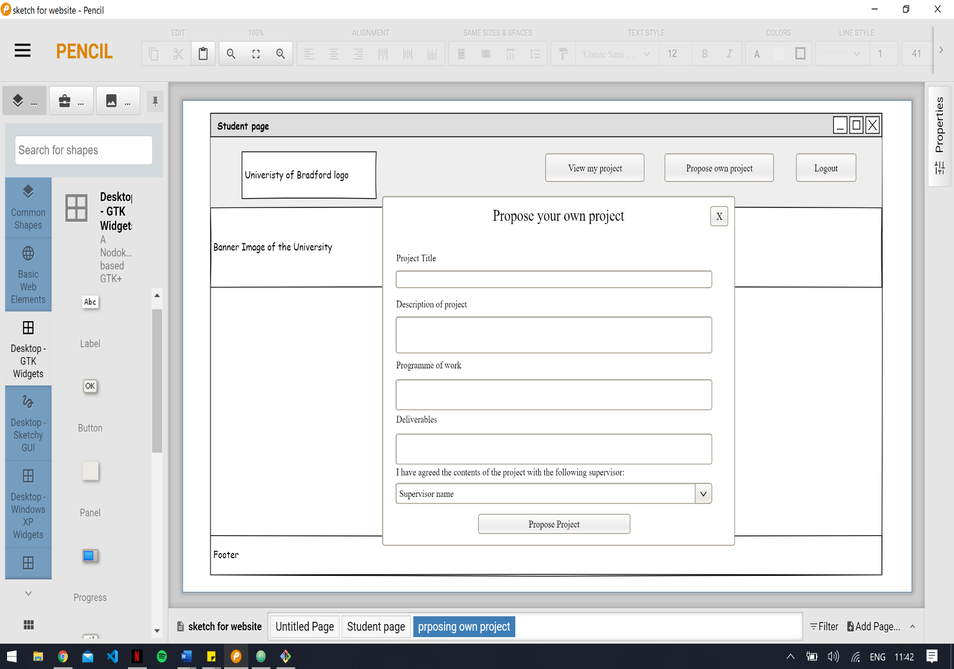

This is the popup for a student to propose a project page.

All fields are required to be filled.

Once the propose project button is clicked it initiates dialogue for function 4 (propose project).

**View my project pop up**

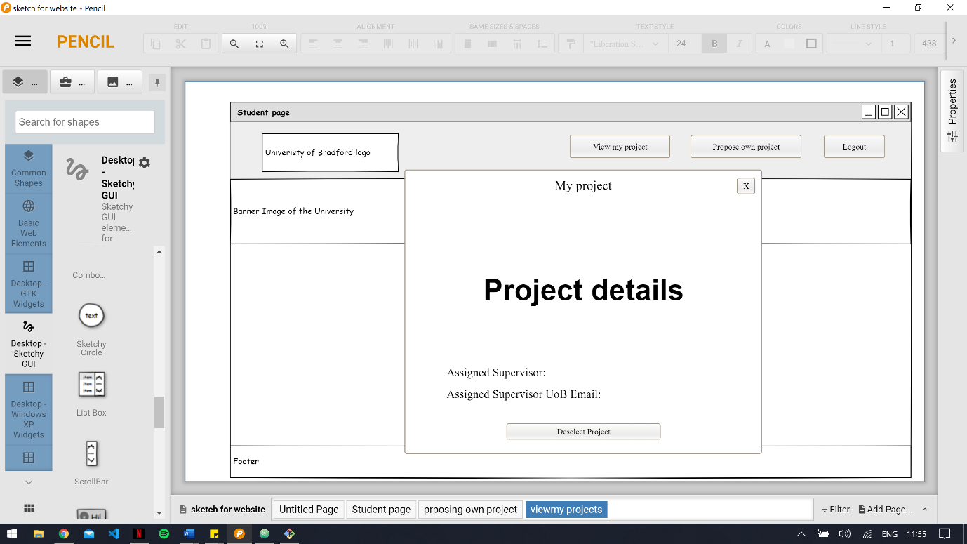

This is the popup for a student to view their project and their allocated supervisor (function 12- view allocated supervisor).

The deselect button initiates the dialogue for function 5(choose projects), as they can deselect the project they have chosen or proposed.

**Supervisor page**

This is the page supervisors are redirected to when logged in.

Three buttons are located on the top right of the navigation bar which will be used for logging out of the FYPA system, going to the edit projects page, and viewing all students allocated to the supervisor.

The logout button initiates dialogue for function 2 (login/logout for all users) to logout the system and be redirected to login page.

The Edits projects button redirects the supervisor to the Supervisor Edit page.

The view allocated student button presents a pop up to display the supervisors allocated students and initiate dialogue for function 8 (view allocated students).

Table displays all projects and if button is selected table displays projects originated by the supervisor logged into the system (function 3 view projects). Able to toggle between both tables

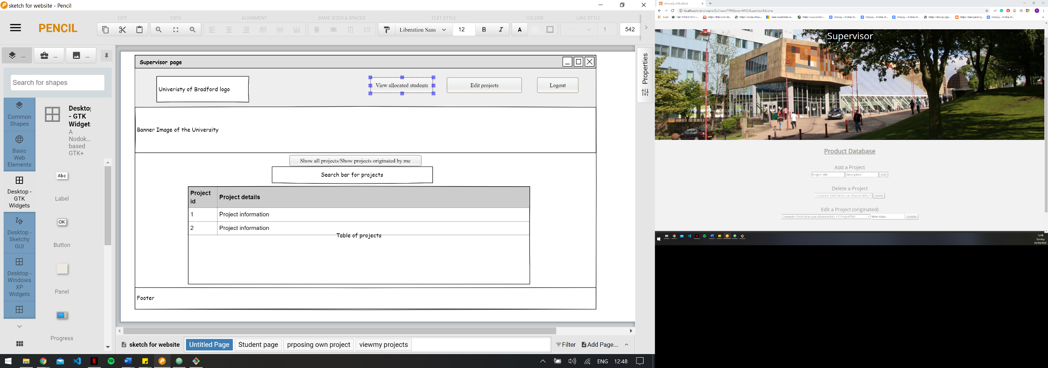

**Supervisor Edit Page**

Three buttons are located on the top right of the navigation bar which will be used for logging out of the FYPA system, going to the Supervisor page, and viewing all students allocated to the supervisor.

The logout button initiates dialogue for function 2 (login/logout for all users) to logout the system and be redirected to login page.

The View projects button redirects the supervisor to the Supervisor page to view their originated projects or all projects.

Forms will take supervisor input to either add, delete or edit their projects. The add, delete or update buttons initiate dialogue for functions 7.1, 7.2 and 7.3 respectively (add projects, delete project and edit projects).

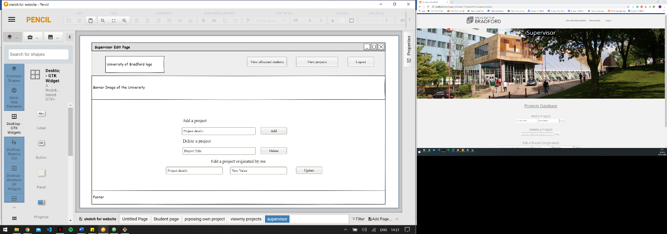

**View allocated students pop up**

This is the view allocated students pop up that appears on both the Supervisor page and Supervisor Edit page once the supervisor clicks the View allocated students’ button in the navigation bar.

This is for a supervisor to see the students they are supervising and their projects (function 8 - view allocated students).

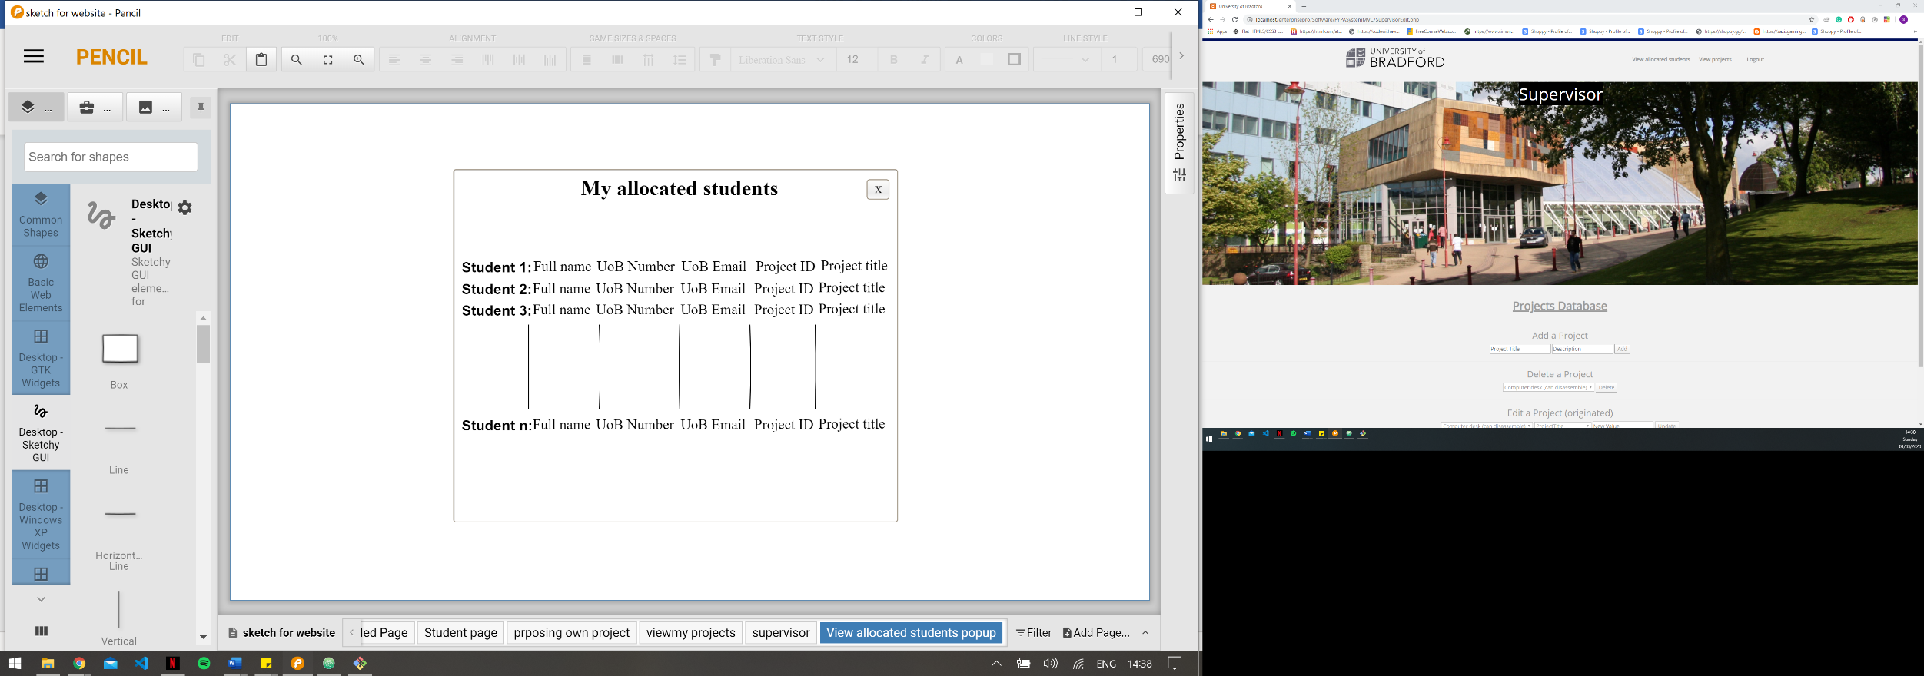

**Module Coordinator page**

This is the page the Module Coordinator is redirected to when logged in.

Two buttons are located on the top right of the navigation bar which will be used for logging out of the FYPA system and going to the Admin panel on the Module Coordinator edit page.

The logout button initiates dialogue for function 2 (login/logout for all users) to logout the system and be redirected to login page.

The Admin panel button redirects to the Module Coordinator Edit page.

Table displays all projects in the FYPA system (function 3 view projects).

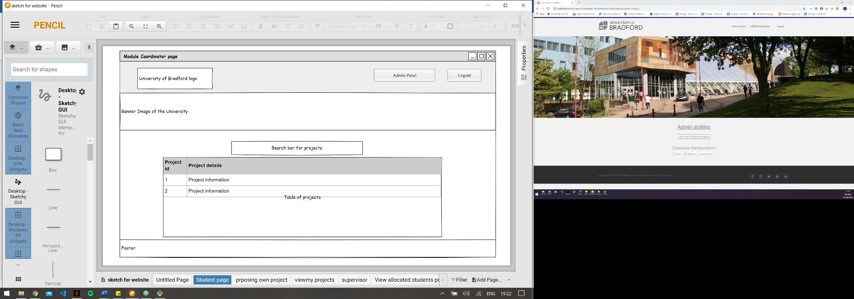

**Module Coordinator Edit page**

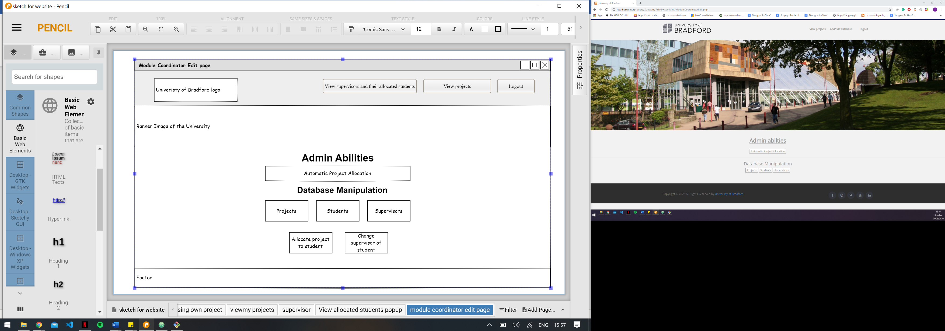

Three buttons are located on the top right of the navigation bar which will be used for logging out of the FYPA system, going to the Module Coordinator page to view all projects in the system, and viewing all the supervisors and their allocated students.

The logout button initiates dialogue for function 2 (login/logout for all users) to logout the system and be redirected to login page.

The View projects button redirects the supervisor to the Module Coordinator page to view all projects.

The View supervisors and their allocated students button initiates dialogue for function 11 (view supervisors and their allocated students) to present a pop up to display a table of supervisors, along with the students they are supervising, and the project allocated to each student.

The projects button initiates the dialogue for function 7(Handling Projects), and allows the module coordinator to add, edit and delete projects from the system.

The students button initiates the dialogue for function 9(Handling Students) and allows the module coordinator to add, edit and delete students to the system.

The supervisors button initiates the dialogue for function 10 (Handling Supervisors) and allows the module coordinator to add, edit and delete students from the system.

The allocate project to a student button initiates the dialogue for function 13(Allocate Project to Student) which allows the module coordinator to manually allocate a project to a student.

The change supervisor of student button initiates dialogue for function 14(Allocate Student for Supervisor) which allows the module coordinator to allocate a student to a project

The automatic project allocation button initiates the dialogue for function 6 (Automatic student allocation) which allocates the students between supervisors to assure a roughly equal number of students are being supervised by each supervisor.

**View supervisors and their allocated students pop**

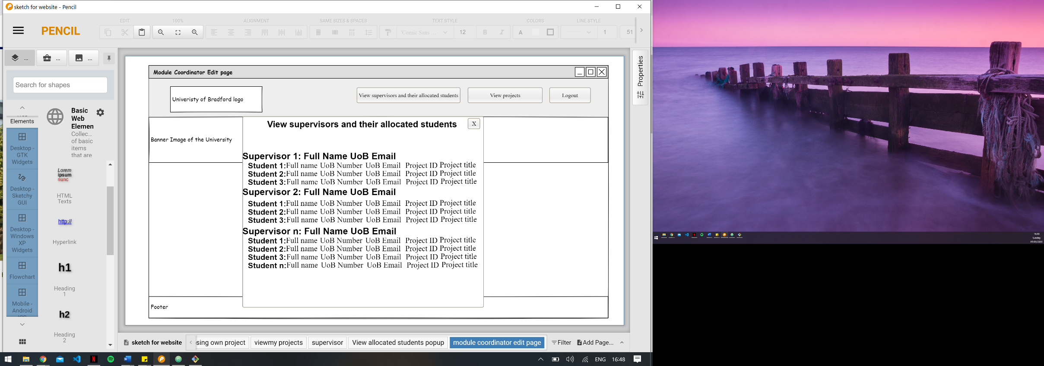

The View supervisors and their allocated students button initiates dialogue for function 11 (view supervisors and their allocated students) to present a pop up to display a table of supervisors, along with the students they are supervising, and the project allocated to each student for the module coordinator.

# Technical and professional issues

**Data Protection:** Information stored about the students, supervisors and module coordinator are susceptible to data breach. Only the module coordinator can see information about all other users of the system. For stored information about students the module coordinator needs to delete all outdated student details from the system. The module coordinator must keep the information about supervisors in the department up to date i.e. if a supervisor joins, leaves or their details change.

**Security**: The passwords for all users in the FYPA System will be encrypted to ensure that if the system is breached other account details will not be stolen. The system will not allow students access to the supervisors and module coordinator pages. Similarly, the supervisor and module coordinator will not be allowed unauthorized access to other users of the system’s pages.

**Economic Impact:** The current system has a lot of manual work. At the end of every academic year, every final year and MSc student selects a project towards their academic degree. After submitting their choices, the module coordinator allocates each of these students to a supervisor. This procedure is carried out manually and is time consuming for the module coordinator. The FYPA System will get rid of the manual work and allocate students who selected a project to their supervisor automatically at the click of the button by the module coordinator.

**Risks:** It’s possible for all first and second year students at the University of Bradford (UoB) to register to the proposed FYPA system, as well as anyone who has UoB email can register and gain access to the system. To try solve this, we asked the client for a whitelist of final year and master student in the Computing Department at UoB to ensure that only legitimate final year and master student of UoB can register and therefore gain access to the system. However, because of data protection we cannot get access to the data needed to ensure this. Therefore, this system is vulnerable to be used by unauthorized students who are aware the FYPA System exists.